
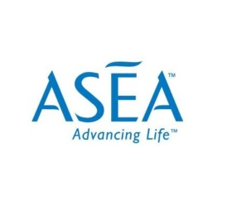
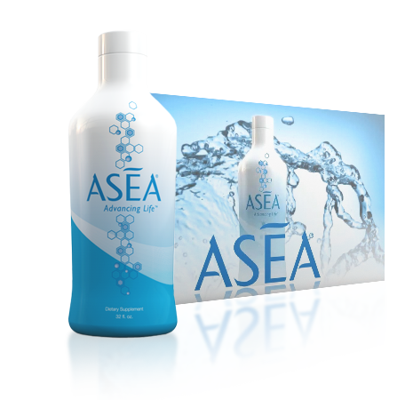
Discover the science behind

The most significant athletic and medical breakthrough of our lifetime.
Guest Speaker:
TERRY LATHAM
TERRY LATHAM IS ONE OF THE TOP BUSINESS LEADERS IN ASEA AND SITS ON THE GLOBAL ADVISORY COUNCIL. COME FIND OUT WHY THIS DISCOVERY IS AS BIG AS THE DNA & ANTIBIOTICS.
LUNCH AND LEARN
When: Wednesday, October 12th
Time: 11:30 – 1:00
Where: River Crossing Country Club
500 River Way, Spring Branch
Cost for Lunch: $11 per person all inclusive

